

Foundations of Programming

Assignment No.: 22
PROBLEM STATEMENT: Write a menu driven program in C to perform various string operations using in-built functions.

OBJECTIVE:

- To understand the concept of strings in the C programming language.
- To learn how to use built-in string functions for string manipulation.
- To perform operations such as length calculation, copying, concatenation, comparison, and reversal using menu options.
.

THEORY:
In the C programming language, a string is a sequence of characters terminated by a null character ('\0'). Strings are stored in character arrays and manipulated using functions available in the string.h header file.
Common built-in string functions include strlen() for finding the length of a string, strcpy() for copying one string to another, strcat() for concatenating two strings, and strcmp() for comparing two strings.
A menu driven program allows the user to select different operations from a list of options. Based on the user’s choice, the corresponding string function is executed. This approach makes the program interactive and easy to use.

PLATFORM: Linux
ALGORITHM:

Step 1: Start
Step 2: Input two strings str1 and str2 from user
Step 3: Display menu with options: 1. Length 2. Copy 3. Concatenate 4. Compare 5. Reverse 6. Exit
Step 4: Accept user's choice
Step 5: Based on choice, execute corresponding string function
1 → strlen(str1) → Display length
2 → strcpy(dest, str1) → Display copied string
3 → strcat(str1, str2) → Display concatenated string
4 → strcmp(str1, str2) → Display equal/not equal
5 → strrev(str1) [or manual reverse] → Display reversed string
6 → Exit
Step 6: Repeat from Step 3 until user selects Exit
Step 7: Stop

FLOWCHART:
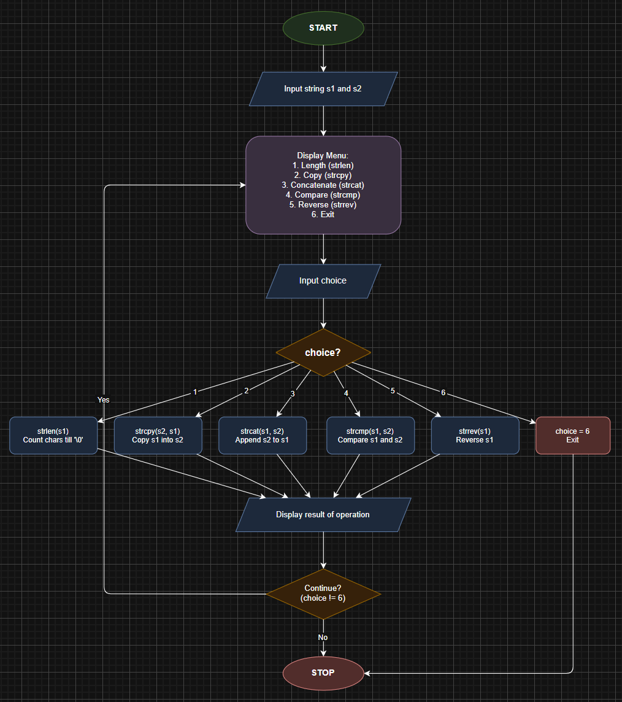
CODE:
#include <stdio.h>
#include <string.h>

int main() {
char str1[100], str2[100], dest[200];
int choice, i, len;
char temp;

printf("Enter first string: ");
scanf("%s", str1);
printf("Enter second string: ");
scanf("%s", str2);

do {
printf("\n===== STRING OPERATIONS MENU =====\n");
printf("1. Length of String\n");
printf("2. Copy String\n");
printf("3. Concatenate Strings\n");
printf("4. Compare Strings\n");
printf("5. Reverse String\n");
printf("6. Exit\n");
printf("Enter your choice: ");
scanf("%d", &choice);

switch (choice) {
case 1:
printf("Length of str1 = %d\n", (int)strlen(str1));
printf("Length of str2 = %d\n", (int)strlen(str2));
break;

case 2:
strcpy(dest, str1);
printf("Copied string: %s\n", dest);
break;

case 3:
strcpy(dest, str1);
strcat(dest, str2);
printf("Concatenated: %s\n", dest);
break;

case 4:
if (strcmp(str1, str2) == 0)
printf("Strings are equal\n");
else
printf("Strings are not equal\n");
break;

case 5:
len = strlen(str1);
for (i = 0; i < len / 2; i++) {
temp = str1[i];
str1[i] = str1[len - 1 - i];
str1[len - 1 - i] = temp;
}
printf("Reversed: %s\n", str1);
break;

case 6:
printf("Exiting...\n");
break;

default:
printf("Invalid choice! Try again.\n");
}
} while (choice != 6);

return 0;
}

INPUT: Two strings entered by the user.

OUTPUT: Displays results of different string operations such as length, copy, concatenation, and comparison.

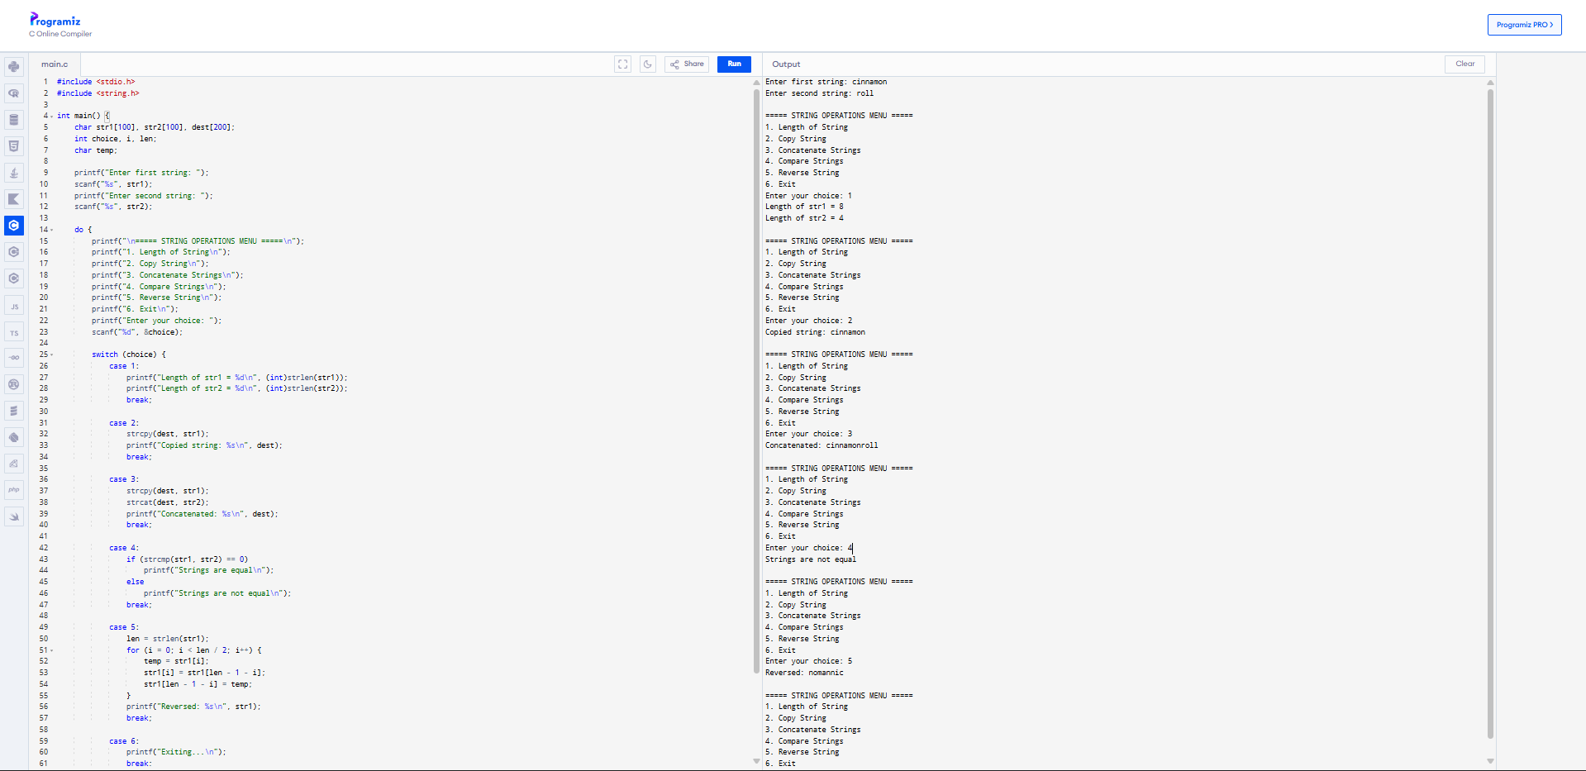

CONCLUSION: Thus, the C program successfully demonstrates different string operations using built-in functions through a menu driven approach, making the program interactive and easy to use.

